Final Project – I

Story:

Leon and Delgo arrive on a planet filled with exotic flora and an expansive fog. They land in a small clearing. They are awestruck by the planet’s beauty and decide to explore. Fortunately, there is an existing path for them to follow, and they make sure to keep to it. As they continue along the path, the fog around them grows. Then, Delgo notices a cute little tree (that’s alive!) and as he’s looking at its face, a larger tree captures him. Leon, too consumed in his fear of the unknown, continues walking down the path and doesn’t notice he left Delgo behind. When the fog finally envelops Leon (or just when he’s reached the end of the path), he notices Delgo is gone and then hears a twig crack inside the forest/dense foliage. Given no other choice, Leon leaves the path and explores the planet further. While Leon is exploring, the camera flashes back to Delgo every once in a while to him sad and trapped by the tree. Leon, however, is gaining confidence and enjoying the planet. He finds a mushroom grove and jumps around on the bouncy mushroom tops and finds himself amidst a forest of living plants the further he gets. They have no problem with him, at first, but as the scene continues he loses his footing in his excitement and steps directly on one of the baby flowers. All of the foliage turns to him and starts to chase him back to the starship. Delgo escapes the tree that captured him by threatening him with fire from a lighter he had in his pocket and meets Leon at the starship. They leave.

NOTE: We may not do fog because of how long it takes to render

|  |  |
| --- | --- |
| William Benda | Charles Griffin |
| **Modeling:**   * Environmental Foliage   + Plants   + Trees   + Mushrooms * Tree character   (Filling the scene with this foliage)  **Animation:**   * Walking Cycles * Animating Tree character and Delgo * Misc. Particle Systems (Fire, etc.) | **Modeling:**   * Environment Terrain (Floor) * Environment characters   + Little tree   + Mushroom/Toad * Lighting/Fog * Sound   **Animation:**   * Facial Animation * Detailed character animation * Leon scenes |

Modeling Screenshots:

*Some models used from previous projects this semester and last semester

The start of foliage

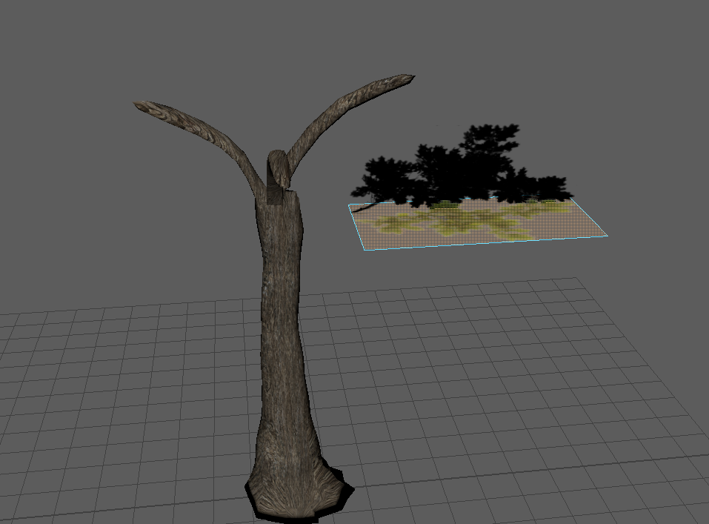

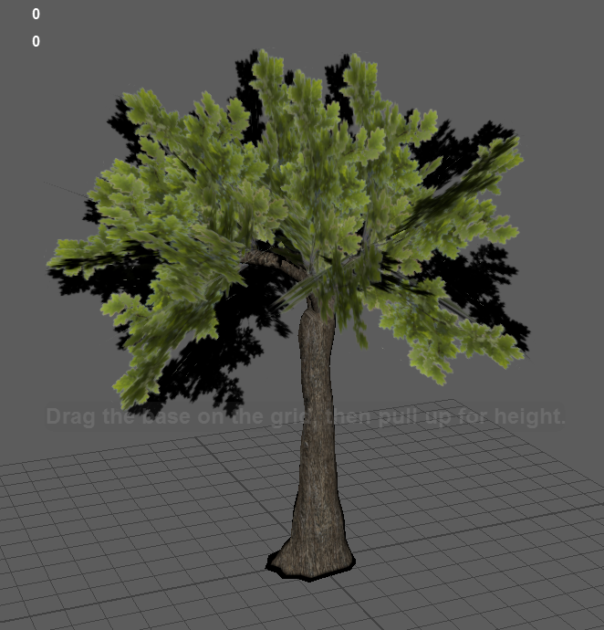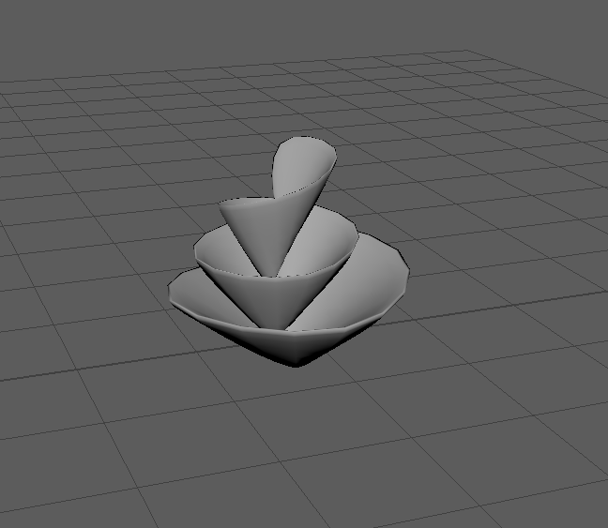

Mushroom (Leon bounces on these)

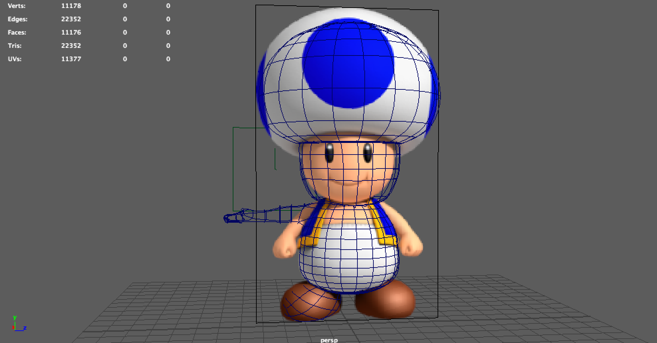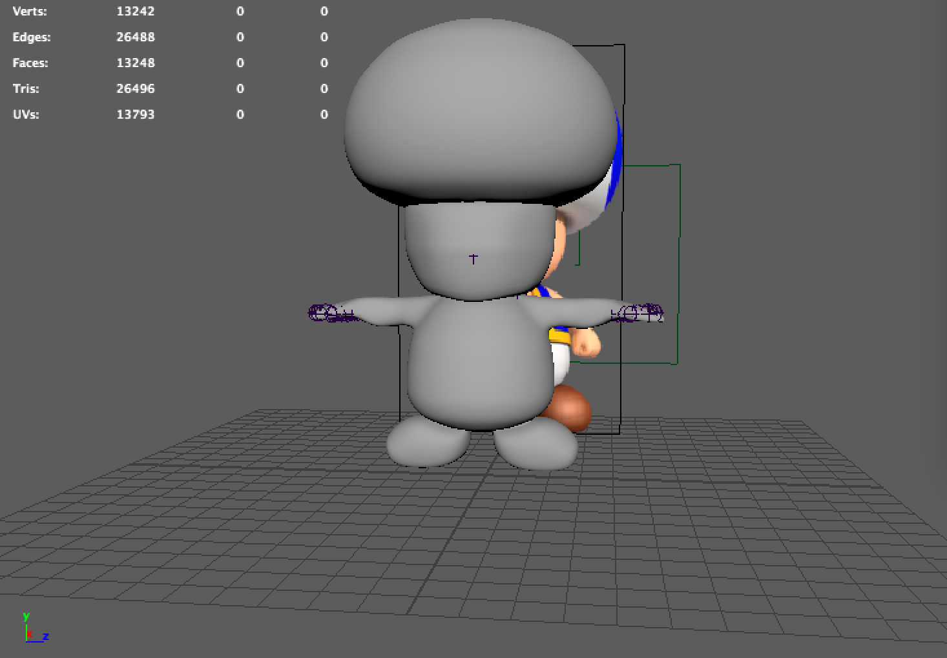

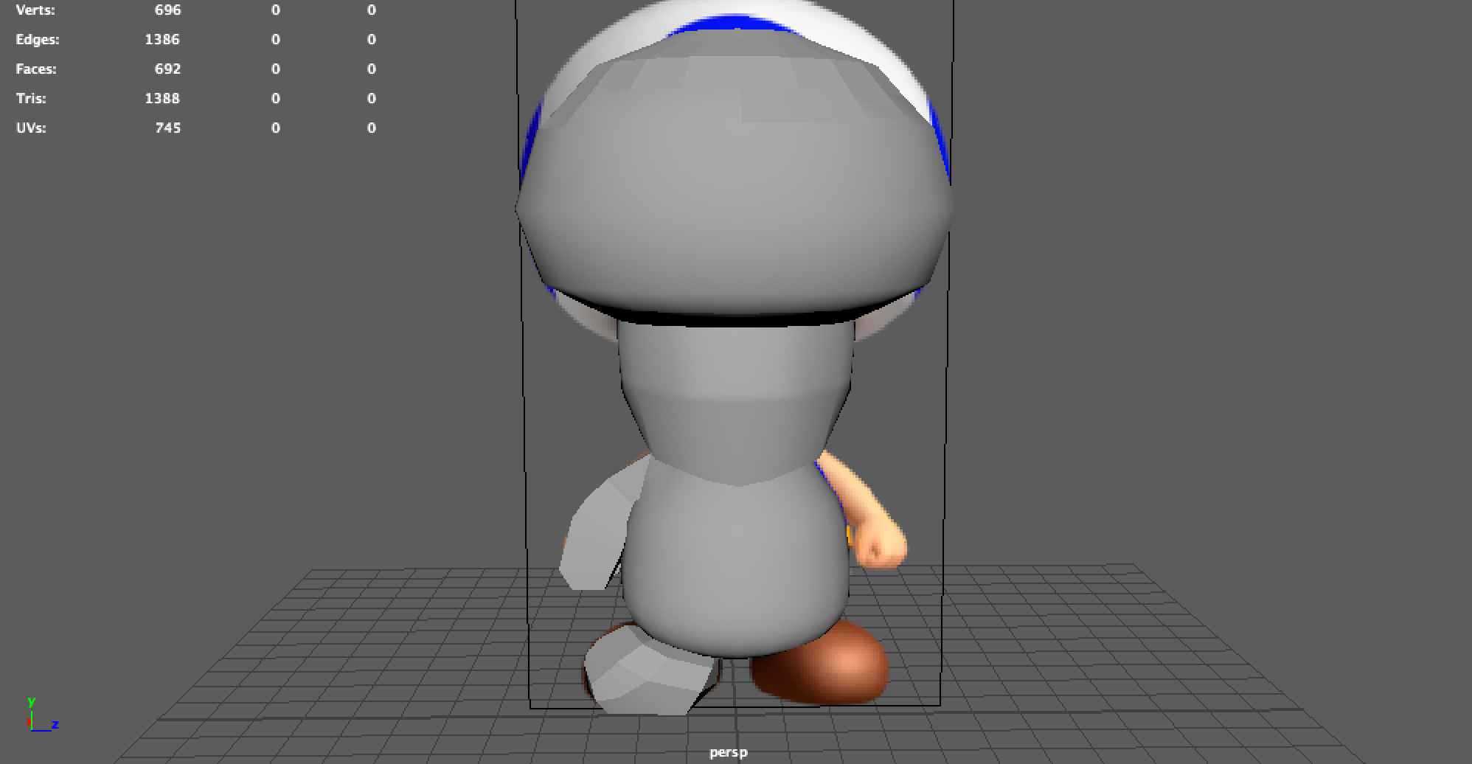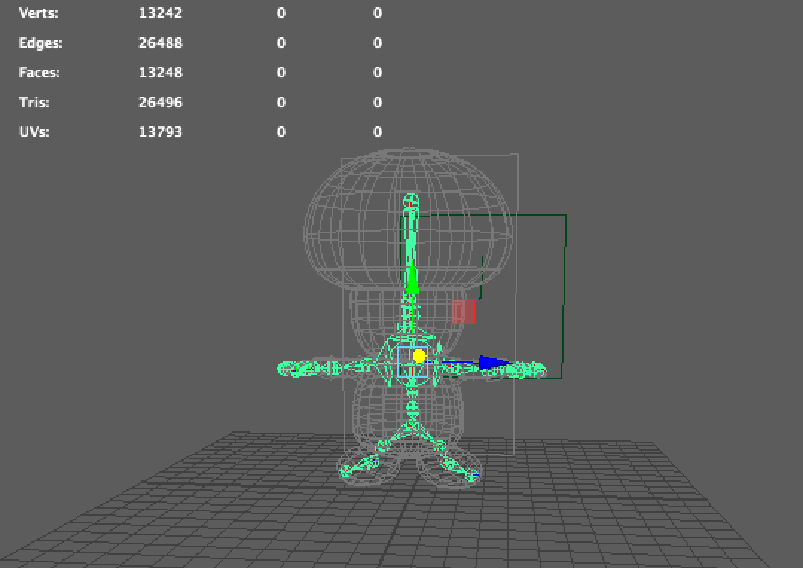

Little Tree

